AP Statistics Name:
Special Problem 7 (S-2016)
Directions: Complete the following problems as you would on the AP Exam. Show all your work. Indicate clearly the methods you use, because you will be graded on the correctness of your methods as well as on the accuracy and completeness of your results and explanations. This is an individual effort. The internet is not a legal resource.
Question 1:
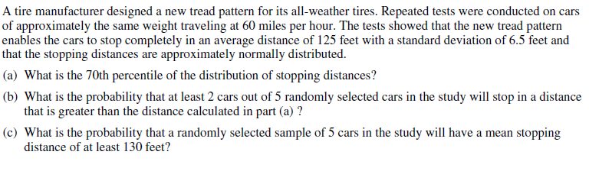

Problem 2:
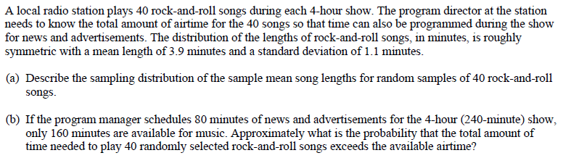

Problem 3:
