8.1 - Confidence Intervals: The Basics (pp. 475-492)
Activity. Suppose we have a Normally distributed population with mean μ = M and standard deviation σ = 20. As we saw in Chapter 7, if we take repeated random samples from the population, compute the sample means and average them, we have an unbiased estimator of the population mean.
The calculator command randNorm generates random values from a Normal distribution. Using the number generated by Mr. Mayo, determine an interval of reasonable values for the population mean μ.

Point estimator and point estimate. If we had to give a single number to estimate the value of M that Mr. Mayo chose, what would it be?
This value is known as a point estimate. Why should it make sense to use this number to estimate the actual mean μ of the population?
A point estimator is a statistic that provides an estimate of a population parameter. The value of that statistic from a sample is called a point estimate.
The ideal point estimator will have no bias and low variability.

Example. In each of the following settings, determine the point estimator you would use and calculate the value of the point estimate.
(a) The makers of a new golf ball want to estimate the median distance the new balls will travel when hit by a mechanical driver. The select a random sample of 10 balls and measure the distance each ball travels after being hit by the mechanical driver. The distances in yards are:
285 286 284 285 282 284 287 290 288 285

(b) The golf ball manufacturer would also like to investigate the variability of the distance traveled by the golf balls by estimating the IQR.

(c) Suppose the WCHS Math Department wants to know what proportion of its students own a graphing calculator, so they take a random sample of 100 students and find that 28 own a graphing calculator.

The Idea of a Confidence Interval
Let’s use the point estimator we found earlier to determine what an interval of reasonable values for the unknown population mean, μ = M.
To address this task, we ask another: How would the sample mean $\overline{x}$ vary if we took many SRSs of size 16 from this same population? The sampling distribution of $\overline{x}$ describes how $\overline{x}$ varies in repeated samples. Let’s recall facts about this distribution:
Shape:
Center:
Spread:
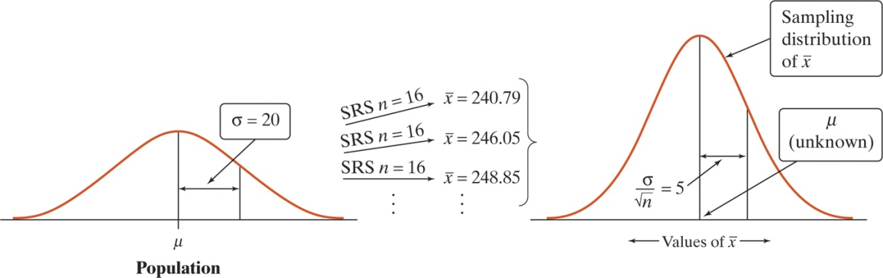
With all that in mind, we will now attempt to capture statistical estimation in a nutshell.
Activity (cont).
1. To estimate μ, use the mean $\overline{x}$ of the random sample: ______________ . This is our point estimate. Since we do not expect $\overline{x}$ to be exactly equal to μ, we want to say how accurate our estimate is.
2. In repeated samples, the values of $\overline{x}$ follow a Normal distribution with mean μ and standard deviation $σ_{\overline{x}}=\frac{σ}{\sqrt{n}}=\frac{20}{\sqrt{16}}=5$.
3. The 95 part of the 68-95-99.7 rule for Normal distribution says that $\overline{x}$ is within 2 standard deviations of the population mean μ in about 95% of all samples of size n = 16.
4. Whenever $\overline{x}$ is within 10 points of μ, μ is within 10 points of $\overline{x}$. This happens in about 95% of all possible samples. So the interval from  $\overline{x}$-10 to $\overline{x}$+10 “captures” the population mean μ in about 95% of all samples of size 16.  5. If we estimate that μ lies somewhere in the interval  we would be calculating this interval using a method that captures the true μ in about 95% of all possible samples of this size. | 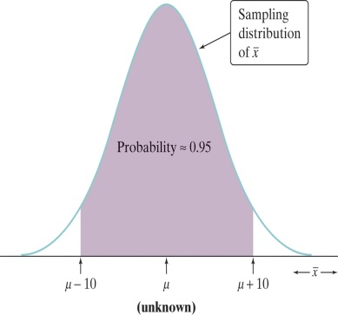
The big idea is that the sampling distribution of $\overline{x}$ tells us how closed to μ the sample mean $\overline{x}$ is likely to be. Statistical estimation just turns that information around to say how close to $\overline{x}$ the unknown population mean μ is likely to be.
We created what is termed a 95% confidence interval for μ.
All confidence intervals will have the form:

A confidence interval for a parameter has two parts:
(1) An interval calculated from the data which has the form:

The point estimate is our best guess for the value of the unknown parameter. The margin of error shows how close we believe our guess is, based upon the variability of the estimate in repeated samples of size n.

(2) A confidence level C, which gives the overall success rate of the method for calculating the confidence interval. That is, in C% of all possible samples, the method would yield an interval that captures the true population parameter value.

Note about margins of error: The margin of error in a confidence interval accounts for the variability due only to random selection or random assignment; it does not compensate for any bias in the data collection process. For example, if the sample was not random or the questions were worded poorly, you should not have much confidence at all.

Interpreting Confidence Levels and Confidence Intervals
The confidence level is the overall capture rate if the method is used many times. The figure below illustrates the behavior of the confidence interval $\overline{x}±10$ for the mystery mean. Imagine taking repeated samples of size 16. The first sample has a mean of 240.79, the second has 246.05, the third has 248.85 and so on. The sample mean varies from sample to sample, but when you use the formula $\overline{x}±10$ to get an interval based on each sample, 95% of these intervals capture the unknown population parameter.
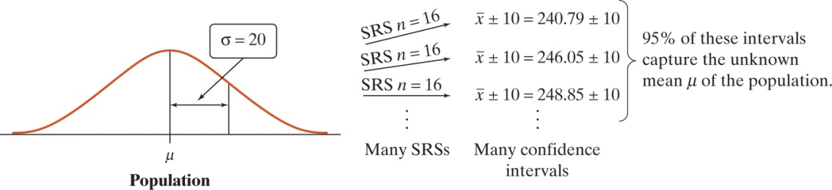

The figure to the right illustrates the idea of a confidence interval in a different form. It shows the result of drawing many SRSs from the same population and calculating a 95% confidence interval from each sample. The center of the interval is $\overline{x}$ and therefore varies from sample to sample.  Notice:  - The center $\overline{x}$ of each interval is marked by a dot;  - The distance from the dot to either endpoint is the margin of error;  - 24 of the 25 intervals (96%) contain the value of μ.  - If we took all possible samples, 95% of the resulting confidence intervals would capture μ. | 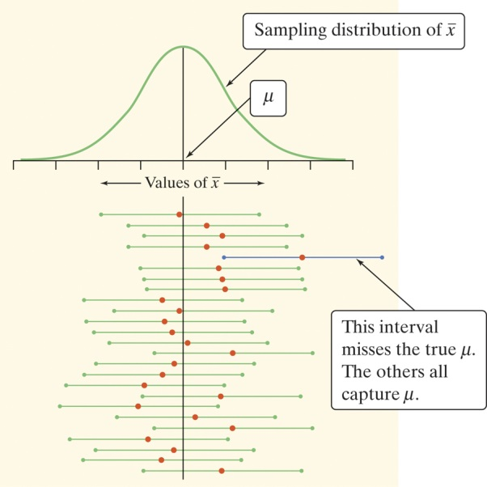

Interpreting Confidence Levels and Confidence Intervals (Mantra)
Confidence level: To say we are 95% confident is shorthand for “95% of all possible samples of a given size from this population will result in and interval that captures the unknown parameter.

Confidence interval: To interpret a C% confidence interval for an unknown parameter, say, “We are C% confident that the interval from _____ to _____ captures the actual value of the [population parameter in context].
Note: Every time you are asked to compute a confidence interval, you are expected to interpret the confidence interval. You are only expected to interpret a confidence level when you are specifically asked to do so.
Do not say “There is a 95% probability that the true mean falls in the interval ____ to ____. This is WRONG.
Example: According to www.gallup.com, on August 13, 2010, the 95% confidence interval for the true proportion of Americans who approved of the job Barack Obama was doing as President was 0.44 ± 0.03. Interpret the confidence interval and the confidence level.

Constructing a Confidence Interval
Calculating a Confidence Interval

The confidence interval for estimating a population parameter has the form:

Statistic ± (critical value)•(standard deviation of statistic)

where the statistic we us is the point estimator for the parameter.
The margin of error is the critical value times the standard deviation of the statistic. This means the margin of error gets smaller when:

Using Confidence Intervals Wisely
Before calculating a confidence interval for μ or p, there are 3 important conditions you must check:
1. Random: To make inferences about a larger population or cause and effect, the data collection process must correctly use randomization. If not, our estimates might be biased, and we should not have any confidence that the intervals we calculate actually contain the value of the parameter we are trying to estimate.

2. Normal: To calculate the appropriate critical value to use in our confidence interval, we must assume that the sampling distribution of the statistic we are using is approximately Normal. If this condition is violated, the actual capture rate of our intervals will often be less than the stated capture rate. For example, if we take small samples from a skewed population and calculate 95% confidence intervals, fewer than 95% will actually capture the value of the population parameter.

3. Independent: To use familiar formulas for the standard deviation of a statistic, the observations in the sample must be independent. If this condition is violated because we are sampling without replacement, then the actual capture rate will be larger than the stated capture rate.

The three conditions are related to the three components of a confidence interval (statistic, critical value, standard deviation of the statistic).
- The Random condition helps to ensure the statistic is unbiased.
- The Normal condition ensures we are using the correct critical value.
- The Independent condition ensures that we are using the correct formula for the standard deviation of the statistic.

There are two more important reminders about computing and interpreting confidence intervals:
- Our method of calculation assumes that the data come from an SRS of size n from the population of interest.
  - If data were collected from a stratified sample and the choice of strata was appropriate, but we use the standard formula for the CI, our intervals will be wider than they need to be.
- The margin of error in a confidence interval covers only chance variation due to random sampling or random assignment.

HW: Read Sec 8.1; do problems 5-13 odd, 17, 19-24 on pp. 489-492

