Section 4.2 (Part 2) pp. 240-251
How to Experiment Well
1. Random Assignment
The remedy for confounding in the SAT Prep course example is to do a comparative experiment in which some students are taught in the classroom and other similar students take the online course.
Comparison alone is not enough to produce results that can be trusted. If the treatments are given to groups that differ greatly when the experiment begins, bias will result. The solution is random assignment.
Definition: In an experiment, random assignment means that experimental units are assigned to treatments at random, that is, using some chance process.
Example - 50 students have agreed to participate in an experiment to compare the online SAT course with traditional classroom instruction. Describe how you would randomly assign the two instructional methods.

2. Three Principles of Experimental Design
Logic of randomized comparative experiments:
- Ensures that influences other than the experimental treatments operate equally on all groups.
  - Controls for the effects of other variables.
- Balances out the effects of lurking variables that we cannot control or do not think of on treatment groups.
  - Random assignment forms groups of experimental units that should be similar.
- Since groups are roughly equivalent except for treatments, any differences in average response must be due either to the treatments or to the play of chance in the random assignment.

Principles of Experimental Design
The basic principles for designing experiments are:

1. Control for other variables that might affect the response: Use a comparative design and ensure that only the systematic difference between the groups is the treatment administered.

2. Random Assignment: Use impersonal chance to assign experimental units to treatments. This helps create roughly equivalent groups of experimental units by balancing the effects of other variables that are not controlled on the treatment groups.

3. Replication: Use enough experimental units in each group so that any differences in the effects of the treatments can be distinguished from chance differences between the groups.

Example - Many students regularly consume caffeine to help them stay alert. Thus, it seems plausible that caffeine might increase an individual’s pulse rate. One way to investigate this is to have volunteers measure their pulse rates, drink some cola with caffeine, measure their pulse rate after 10 minutes and calculate difference. Unfortunately, even if every student’s pulse rate went up, we could not attribute it to caffeine.
Explain how to use all three principles of experimental design in the caffeine experiment.

3. Completely Randomized Designs
This diagram details the SAT prep experiment: random assignment, the sizes of the groups and which treatment they receive, and the response variable. 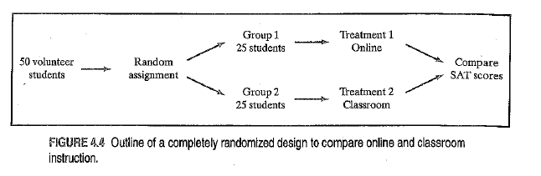
Definition: In a completely randomized design, the treatments are assigned to all the experimental units completely by chance.
- Completely randomized design does not require that each treatment have equal number of experimental units.
- Assignment of treatments must occur completely at random. (The best bet is to choose them using the “hat method.”)
Some experiments include a control group. The primary purpose of a control group is to provide a baseline for comparing the treatments of the other treatments. Refer to example on p. 246.
It should be noted that although many experiments include a control group that receives an inactive treatment, a control group can be given an active treatment. For example, if researchers are only concerned with comparing two active treatments and do not care to determine if they are different than no treatment.

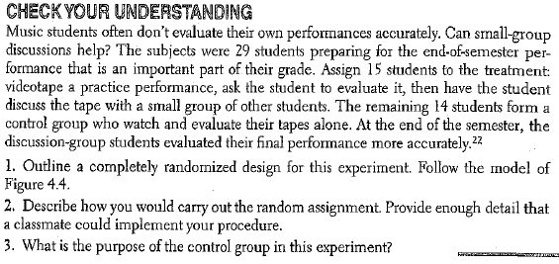

Experiments: What Can Go Wrong?
The logic of a randomized comparative experiment depends on our ability to treat all the subjects the same in every way except for the actual treatments being compared. Good experiments require careful attention to details to ensure that all subjects are really treated identically.

Placebo Effect - The placebo effect is the tendency in humans to show a response whenever they think a treatment is in effect. Well-designed experiments use a control group so that the placebo effect operates equally on both the treatment group and the control group, thus allowing us to attribute changes in the response variable to the explanatory variable.

Double-Blind - In a double-blind experiment, neither the subjects nor those who interact with them and measure the response variable know which treatment a subject received.
Single-Blind - Some experiments cannot be carried out in a double-blind manner. Sometimes the subjects know what treatment they are receiving. If those who interact with them do not know how the individuals are treated, the experiment is single-blind.
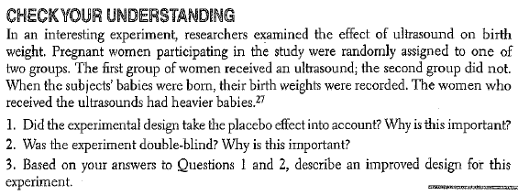

4. Inference for Experiments - In an experiment, researchers usually hope to see a difference in the responses so large that it is unlikely to happen just because of chance variation. We can use the laws of probability, which describe chance behavior, to learn whether the effects are larger than we would expect to see if only chance were operating. If they are, they are called statistically significant.
Definition: An observed effect so large that it would rarely occur by chance is called statistically significant.
If we observed statistically differences among groups in a randomized comparative experiment, we have good evidence that the treatments actually caused these differences. A statistically significant association in data from a well-designed experiment does imply causation.

HW: 57, 61, 64, 66, 69, 71, 74

