Section 4.1 - Sampling & Surveys (Part 1) pp. 206-223
1. Populations and Samples. Statistics is largely practiced in order to make inferences about populations of individuals based upon a sample chosen to represent the population. In this section, we are going to explore how to sample populations.
Definitions:
The population in a statistical study is the entire group of individuals about which we want information.

A sample is the part of the population from which we actually collect information. We use information from a sample to draw conclusions about the entire population.
Example: Identify the population and sample in each of the following examples:
(a) The student government at a high school surveys 100 of the students at the school to get their opinion about a change in the bell schedule.
(b) The quality control manager at a bottling company selects a sample of 10 cans from the production line every hour to see whether the volume of the soda is within acceptable limits.

2. The Idea of a Sample Survey
The first step in a sample survey is to say exactly what population we want to describe. The second step is to say exactly what we want to measure, that is, to give exact definitions to our variables. The term sample survey is reserved for studies that use an organized plan to choose a sample to represent a population. The final step in planning a survey is to decide how to choose a sample from the population.
It should be noted that a survey or sample survey does not only refer to studies where people are asked questions. Choosing the cans in the example above is a type of sample survey.

3. How to Sample Badly
a. Convenience Samples - A convenience sample is choosing individuals who are easiest to reach.
Example:
- Convenience samples often produce unrepresentative data.
- Convenience samples are almost guaranteed to be biased.
Definition: The design of a statistical study shows bias if it systematically favors certain outcomes.

Note: when asked to identify bias in the design of a statistical study, you are expected to identify the direction of the bias.
Example:

b. Voluntary Samples - A voluntary response sample consists of people who choose themselves by responding to a general appeal. Voluntary response samples show bias because people with strong opinions (often in the same direction) are most likely to respond.
Example:

- Write-in and call-in opinion polls are almost sure to lead to a strong bias.
- Another problem is that people often times respond more than once.

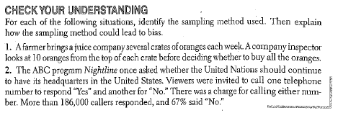

4. How to Sample Well
A sample chosen by chance rules out favoritism by the sampler and self-selection by respondents. Random sampling, the use of chance to select a sample, is central to the principle of statistical sampling.
Definition: A simple random sample (SRS) of size n consists of n individuals from the population chosen in such a way that every set of n individuals has an equal chance to be the sample actually selected.
Example:

- An SRS not only gives each individual an equal chance of being chosen but also gives every possible sample an equal chance of being chosen.
- Often times a Table of Random Digits or a Random Number Generator are used to choose SRSs.
How to Choose an SRS Using Technology
Step 1: Label – Give each member of the population a distinct numerical label from 1 to N.
Step 2: Randomize – Use a random number generator to obtain n different integers from 1 to N.

How to Choose an SRS Using Table D
Step 1: Label - Give each member of the population a numerical label of the same length.
Step 2: Table - Read consecutive groups of digits of the appropriate length from Table D.
- The sample contains the individuals whose labels you find.
- Always use the shortest labels that will cover your population.
- Ignore any group of digits that was not used as a label or that duplicates a label already in the sample.
- Digits can be read in any order but it is recommended to read rows from left to right.
Example. The management company of a local mall plans to survey a random sample of 3 stores to determine the hours they would like to stay open during the holiday season.
a. Use a random number generator to select an SRS of size 3.
b. Use Table D at line 101 to select an SRS of size 3.
Aeropostale Just Sports
All American Burger Mrs. Fields
Arby’s Nike Factory Store
Barnes & Noble Old Navy
Carter’s for Kids Pac Sun
Destination Tan Panda Express
Famous Footwear Payless Shoes
Forever 21 Star Jewelers
GameStop Vitamin World
Gymboree Zales Diamond Store
Haggar

5. Other Sampling Methods
Unfortunately it is usually very difficult to actually obtain an SRS from the population of interest. It is often costly in time and money.
Definition: To select stratified random sample, first classify the population into groups of similar individuals, called strata. Then choose a separate SRS in each stratum and combine these SRSs to form the full sample.
Example:

- Choose the strata based upon facts known before the sample is taken.
- If the individuals in each stratum are less varied than the population as a whole, a stratified random sample can produce better information about the population than an SRS of the same size.

Definition: To take a cluster sample, first divide the population into smaller groups. Ideally, these clusters should mirror the characteristics of the population. Then choose an SRS of the clusters. All individuals in the chosen clusters are included in the sample.
Example:

- Cluster samples are often used for practical reasons.
- They do not offer the statistical advantage of better information about the population that stratified samples do.

Team Work - With your team mates, read and discuss the Sampling at a School Assembly Example on pp. 221-222. Then list the advantages and disadvantages of each plan.
Plan | Advantages | Disadvantages
SRS

Stratified Random Sample

Cluster Sample

Multistage Samples - Most large scale sample surveys are multistage samples that combine two or more sampling methods. A good example is on page 222.

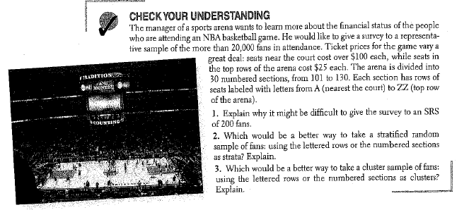

HW: 1-11 odd, 17-25 odd.

