Section 2.1 – Describing Location in a Distribution
1. Measuring Position: Percentiles
Definition: The pth percentile of a distribution is the value with

Example: The stemplot below shows the number of wins for each of the 30 Major League Baseball teams in 2009.
5 | 9
6 | 2455
7 | 00455589
8 | 0345667778
9 | 123557
10| 3
Key: 5 | 9 represents a team with 59 wins.
Find the percentiles for the following teams: (a) The Colorado Rockies, who won 92 games; (b) The New York Yankees, who won 103 games; (c) the Kansas City Royals and the Cleveland Indians, who both won 65 games.

Note: some people define the pth percentile of a distribution as the value with p percent less than or equal to it. In this case it is possible for an individual to be at the 100th percentile.

2. Cumulative Relative Frequency Graphs
When you are given a frequency table for a quantitative variable, it is possible to graphs that depict the percentiles. The table gives the inauguration ages of the first 44 US Presidents.
Age Frequency
40-44 2
45-49 7
50-54 13
55-59 12
60-64 7
65-69 3

Interpreting Cumulative Relative Frequency graphs
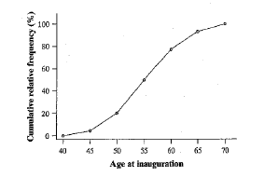 | (a) Was Barack Obama, at 47, unusually young?  (b) Estimate and interpret the 65th percentile of the distribution.

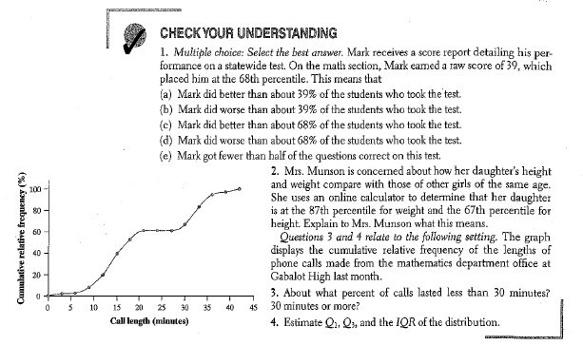

3. Measuring Position: Z-Scores
Another way of measuring position is to determine how many standard deviations above or below the mean an individual data point is. This is called computing a z-score. This process is known as standardizing.
Definition - Standardized value (z-score):
If x is an observation from a distribution that has a known mean and standard deviation, the standardized value of x is

This measure tells how many standard deviations the given data point is from the mean.
Example: 2009 MLB Wins (revisited)
5 | 9  6 | 2455  7 | 00455589  8 | 0345667778  9 | 123557  10| 3  Key: 5 | 9 represents a team with 59 wins. | Mean: 81  Median: 83.5  StDev: 11.43  Minimum: 59  Maximum: 103  Q1: 74  Q3: 88
Use the information provided to find the standardized scores for the (a) Boston Red Sox with 95 wins; (b) Atlanta Braves with 86 wins; and (c) Washington Nationals with 59 wins.

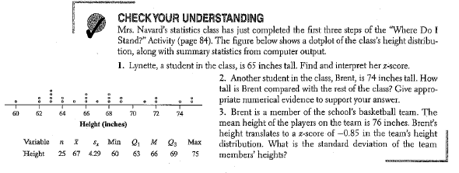
Homework: pp 100-101, 5-15 odd

