AP Stats – Introduction to Alice Programming Name:
Random Number Generation and Sampling
In this activity, we will learn about random number generation. We will then use it to create a simple simulation to draw samples from a population in order to estimate the population proportion.
Starter World: Begin by opening a new Alice world. Place a penguin into the world and size it to take up most of the screen.
Random Color Method: Create a Penguin method and call it randomColor. To begin with we are going to assume the population proportion of males in a colony of penguins is 25%. Choose world in the object tree and then click on the function tab. Cursor down until you see random.
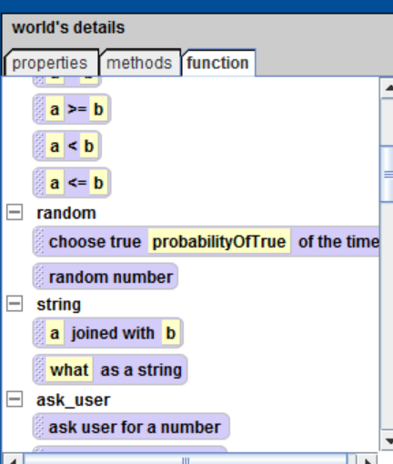
Drag the choose true command into the randomColor method. Then enter .25 (25%) into the drop down. We are going to make male penguins blue and female penguins pink.
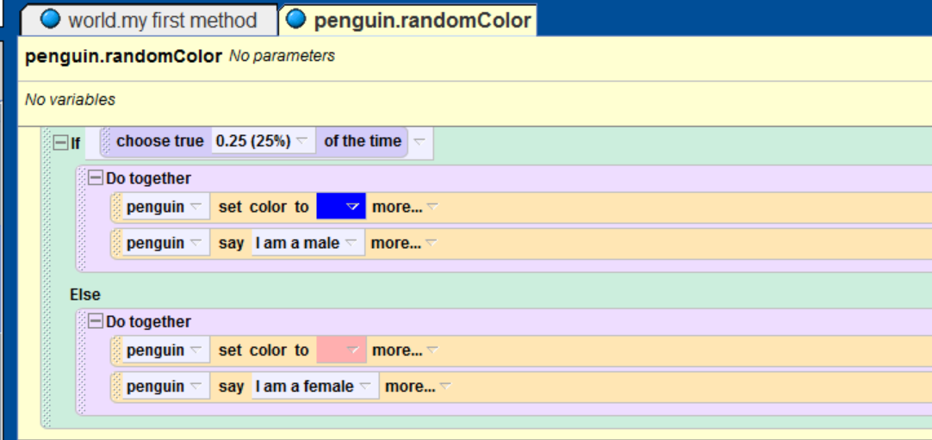
Drag an If/Else statement into the randomColor method and then drag the choose true command into the if field. Drag a Do together command into both the If and Else fields. In the If Do together set the penguin’s color to blue and have the penguin say, “I am a male.” In the Else Do together set the color to pink and have the penguin say, “I am a female.”
Play your world. If your world worked, use the Restart button to run your world 20 times. Keep a tally of how many males and females were in the sample and compute the sample proportion of males from your results.
Sample Proportion: _______________
How does the sample proportion compare to the true population proportion of 0.25?
Simulations
You just created a simple way to simulate sampling from a population to determine the population proportion. However, it is cumbersome to have to repeatedly run the Alice world to obtain a sample of size 20.
Challenge: Your task is to use looping and counters to modify this world to take a sample of size n and count and report the sample proportion. When you think you have accomplished this, call me over to check your world.

- Proper use of looping technique
- Proper use of counters
- Accurate computation and reporting of sample proportion

