Improved Batting Averages Applet
Enter 0.63 for hypothesized value  Enter 0.53 for alternative value  Enter 250 for sample size  Enter 10,000 for number of samples  Press Draw Samples  Enter 0.1 for alpha, press count to verify that the power when p=0.53 is about 97% | 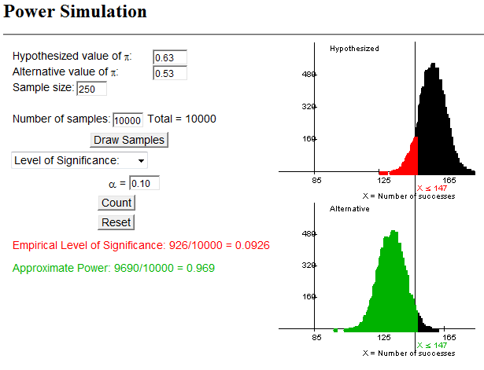
Change alpha to 0.01 and press count | 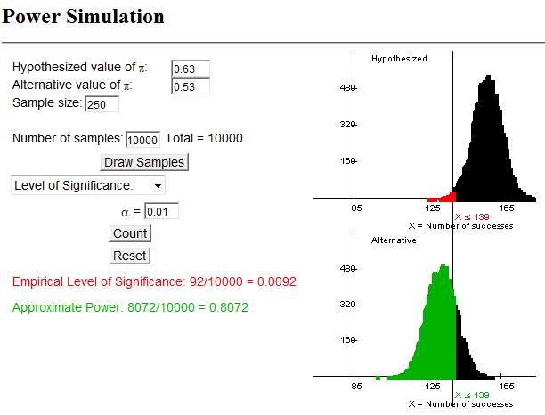
Change the alternative value to 0.50  Press draw samples  Choose level of significance and press count | 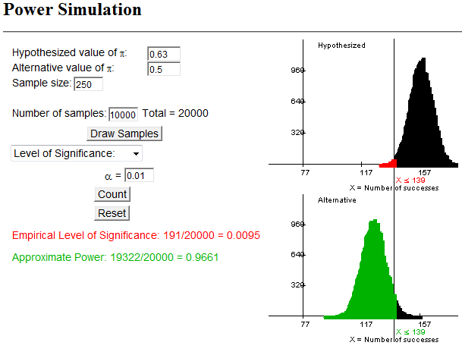

Change the sample size to 100  Press draw samples  Choose level of significance and press count | 