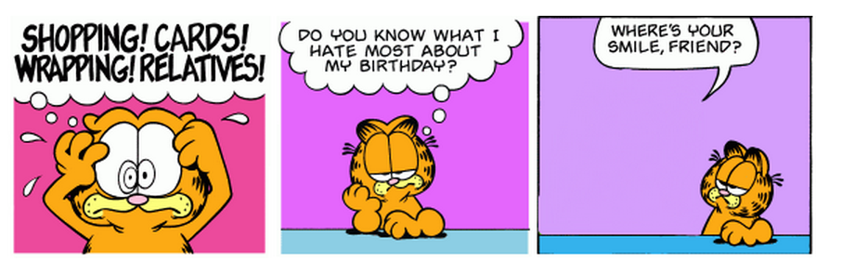
Alice “Garfield Challenge”
Goal: Your goal is to create an animated 3-frame Garfield comic strip using Alice.
- Find a Garfield comic strip or using the Random Garfield Generator at www.bgreco.net/garfield, generate a 3-frame Garfield comic strip that you will animate. Note: you can let the website randomly generate the frames or you can decide to choose the actual strip that one of the frames came from.
- Save a .jpeg of your comic strip to use at the end of your Alice world.
Requirements:
- Create 3 Scenes – Make a separate method for each.
- Each scene must have animation in it – Garfield must move in some manner.
- Fade out/in between scenes.
- Your world should include manipulation of cameras.
- Include a title screen at the start.
- Include a final screen with the .jpeg of the original comic strip on it.
- Extra credit will be given for including music and other unique effects.

Alternative Project – As an alternative to creating a Garfield comic, you can choose a television commercial and create an Alice world that replicates it.

