Section 7.3 - Sample Means (pp. 450-464)
Sample proportions arise most often when we are interested in categorical variables. But when we are looking at quantitative variables, we are interested in other statistics such as the median, mean or standard deviation. In this section we will study the sampling distribution of the sample mean $\overline{x}$ .
Activity
Let’s go back to the hyena experiment. Suppose that we were now interested in determining the average age of the hyenas in the Croatan NF. A team first chose repeated samples of size 5 and determined the mean age of each sample. The distribution of sample means is shown at the right.  Describe the distribution: | 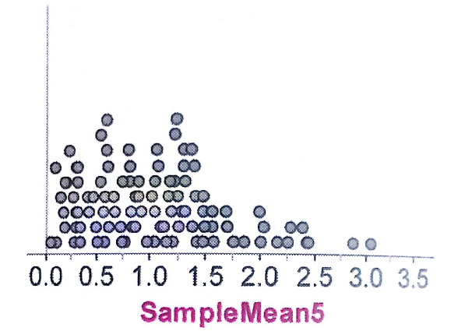
The team then took repeated samples of size 10. The distribution of sample means is shown at the right.  Describe the distribution: | 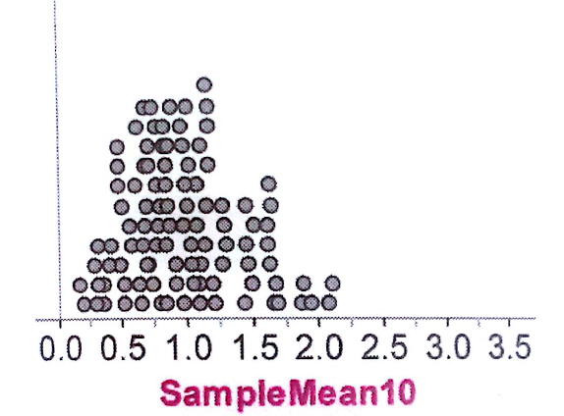
Finally, the team took repeated samples of size 25. The distribution of sample means is shown at the right.  Describe the distribution: | 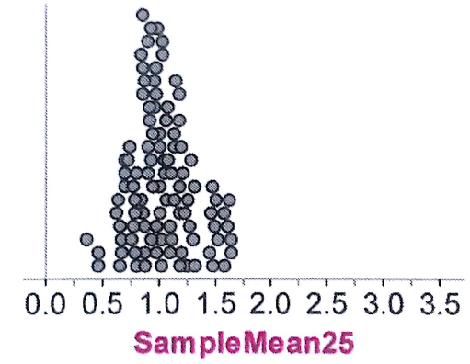

Summarize what happened to the center, shape, and spread as the sample size increased from 5 to 20.

The Sampling Distribution of $\overline{x}$ : Mean and Standard Deviation
Mean and Standard Deviation of the Sampling Distribution of $\overline{x}$

Suppose that $\overline{x}$ is the mean of an SRS of size n drawn from a large population with mean μ and standard deviation σ. Then

- The mean of the sampling distribution of $\overline{x}$ is
- The standard deviation of the sampling distribution of $\overline{x}$ is

as long as the 10% condition is satisfied: n ≤ (1/10)N.

The behavior of $\overline{x}$ in repeated samples is much like that of the sample proportion $\hat{p}$ :

These facts about the mean and standard deviation of $\overline{x}$ are true no matter what shape the population distribution has.

Example - Suppose that the number of movies viewed in the last year by high school students has an average of 19.3 with a standard deviation of 15.8. Suppose we take an SRS of 100 high school students and calculate the mean number of movies viewed by the members of the sample.
(a) What is the mean of the sampling distribution of $\overline{x}$ ?

(b) What is the standard deviation of the sampling distribution of $\overline{x}$ ? Check that the 10 % condition is satisfied.

Sampling from a Normal Population
Sampling Distribution of a Sample Mean from a Normal Population

Suppose that a population is Normally distributed with mean μ and standard deviation σ. Then the sampling distribution of $\overline{x}$ has the Normal distribution with mean μ and standard deviation $σ/{\sqrt{n}}$ , provided the 10% condition is met.
Example - At the P. Nutty Peanut Company, dry-roasted, shelled peanuts are placed in jars by a machine. The distribution of weights in the jars is approximately Normal with a mean of 16.1 ounces and a standard deviation of 0.15 ounces.
(a) Without doing any calculations, explain which is more likely: randomly selecting a single jar and finding that the contents weigh less than 16 ounces or randomly selecting 10 jars and finding that the average content weighs less than 16 ounces.

(b) Find the probability of each event described above.

Note: A common error on the AP Exam is that students often forget to divide by the square root of the sample size.
Check Your Understanding – Complete CYU on p. 456.

The Central Limit Theorem
Many populations are not Normal. However, it turns out that if we take large enough samples from any population, the sampling distribution of the sample mean is Normally distributed. This result is known as the Central Limit Theorem and it will have a major impact on our ability to make inferences about populations.
The Central Limit Theorem (CLT)

Draw an SRS of size n from any population with mean μ and standard deviation . The Central Limit Theorem (CLT) says that when n is large, the sampling distribution of the sample mean $\overline{x}$ is approximately Normal.
The burning question that this theorem quickly solicits is how large does n have to be? Without getting into theory, the quick answer is n = 30. This leads us to now be able to state the Normal condition for sample means.
Normal Conditions for Sample Means

- If the population distribution is Normal, then so is the sampling distribution of $\overline{x}$ . This is true no matter what the sample size n is.

- If the population distribution is not Normal, the Central Limit Theorem tells us that the sampling distribution of $\overline{x}$ will be approximately Normal in most cases if n ≥ 30.

Example - Suppose that the mean number of texts sent during a typical day at a randomly selected high school student follows a right-skewed distribution with a mean of 15 and a standard deviation of 35. Assuming that the students at your school are typical texters, how likely is it that a random sample of 50 students will have sent more than a total of 1000 for a random sample of 50 high school students.
State: What is the probability that the total number of texts in the last 24 hours is greater than 1000 for a random sample of 50 high school students?

HW: Read pp. 450-461, do problems: p. 449 43-46; p. 461 49-63 odd, 65-68.

