Section 5.3 - Conditional Probability & Independence (pp. 318-333)
1. Conditional Probability - Let’s return to the setting of the homeowners example in Section 5.2.
 | High School Grad | Not a HS Grad | Total
Homeowner | 221 | 119 | 340
Not a homeowner | 89 | 71 | 160
Total | 310 | 190 | 500
If we know that a person owns a home, what is the probability that the person is a high school graduate?

If we know that a person is a high school graduate, what is the probability that the person owns a home?

These questions involve conditional probabilities. The name comes from the fact that we are trying to find the probability that one event will happen under the condition that some other event is already known to have occurred. We often use the phrase “given that” to signal the condition.
Definition: The probability that one event happens given that another event is already known to have happened is called a conditional probability. Suppose we know that event A has happened. Then the probability that A happens given that event B has happened is denoted by P(A | B).
Using this notation, we can restate the answers to our two previous questions:
- P(HS grad | Homeowner) =
- P(Homeowner | HS grad)=

2. Calculating Conditional Probabilities
Conditional Probability Formula
To find the conditional probability P(B | A), use the formula
$$P\left(B | A\right)=\frac{P(A∩B)}{P(A)}$$
Example: Given the table below, what is the probability that a randomly selected household with a landline also has a cell phone?
 | Cell Phone | No Cell Phone | Total
Landline | 0.60 | 0.18 | 0.78
No Landline | 0.20 | 0.02 | 0.22
Total | 0.80 | 0.20 | 1.00
Is there a connection between conditional probability and the conditional distribution from Chapter 1?
The answer is yes. The two segmented bar graphs below display the conditional distributions for the Homeowners example.
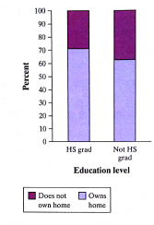 | 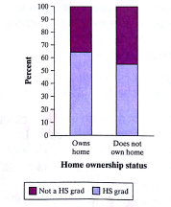

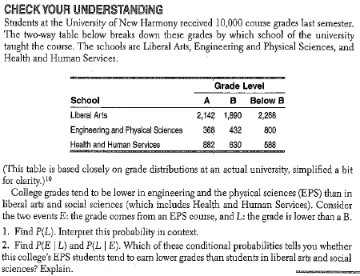

3. The General Multiplication Rule
General Multiplication Rule
The probability that events A and B both occur can be found using the general multiplication rule
$$P\left(A∩B\right)=P\left(A\right)∙P\left(B\right|A)$$
Where P(B|A) is the conditional probability that event B occurs given that event A has already occurred.

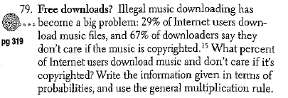

4. Tree Diagrams and the General Multiplication Rule
Shannon hits the snooze bar on her alarm clock on 60% of school days. If she does not hit the snooze bar, there is a 0.90 probability that she makes it to class on time. However, if she hits the snooze bar, there is only 0.70 probability that she makes it to class on time. In a randomly chosen day, what is the probability that Shannon is late to class?

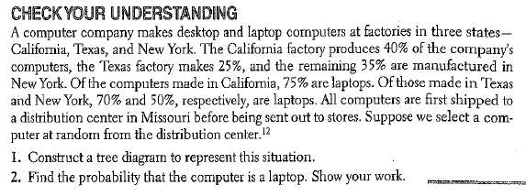

5. Conditional Probability and Independence
Suppose you toss a fair coin twice. Define events A: first toss is a head, and B: second toss is a head. P(A) = 0.5 and P(B) = 0.5. What is P(A|B)? It is the conditional probability that the second toss is a head given that the first toss was a head. The coin has no memory, so P(A|B) = 0.5. In this case P(A|B) = P(A).
Let’s contrast the coin-toss scenario with our earlier homeowner example. The events of interest were A: is a high school graduate and B: owns a home. We already learned that P(B) = 340/500 = 0.68 and P(B|A) = 221/310 = 0.712. That is, we know that a randomly selected member of the sample has a 0.68 probability of owning a home. However, if we know that the randomly selected member is a high school graduate, the probability of owning a home increases to 0.712.
Definition. Two events A and B are independent if the occurrence of one event has no effect on the chance that the other event will happen. In other words, events A and B are independent if
$P\left(A | B\right)=P\left(A\right) and P\left(B | A\right)=P(B)$
Example - Is there a relationship between gender and having allergies? To find out, we used the random the CensusAtSchool web site to randomly select 40 U.S. high school students who completed a survey. The two-way table shows the gender of each student and whether the student has allergies.
 | Female | Male | Total
Allergies | 10 | 8 | 18
No Allergies | 13 | 9 | 22
Total | 23 | 17 | 40
Are the events “female” and “allergies” independent?

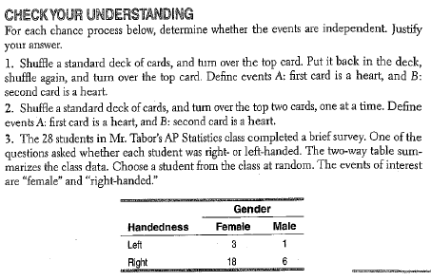

5. Independence: A Special Multiplication Rule - What happens to the general multiplication rule when events A and B are independent?
Multiplication Rule for Independent Events
If A and B are independent events, then the probability that A and B both occur is

$$P\left(A∩B\right)=P\left(A\right)∙P\left(B\right)$$
Example: In baseball, a perfect game is when a pitcher does not allow any hitters to reach base in all nine innings. Historically, pitchers throw a perfect inning - an inning where no hitters reach base - about 40% of the time. So, to throw a perfect game, a pitcher needs to have nine perfect innings in a row.
What is the probability that a pitcher throws nine perfect innings in a row, assuming the pitcher’s performance in an inning is independent of his performance in the other innings.

Example: The First Trimester Screening is a noninvasive test given during the first trimester of pregnancy to determine if there are specific chromosomal abnormalities in the fetus. According to the New England Journal of Medicine in November 2005, approximately 5% of normal pregnancies will receive a false positive result.
Among 100 women with normal pregnancies, what is the probability that there will be at least 1 false positive?

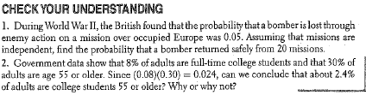

Example: Given the diagram below, what percent of youth with good grades are heavy users of media?
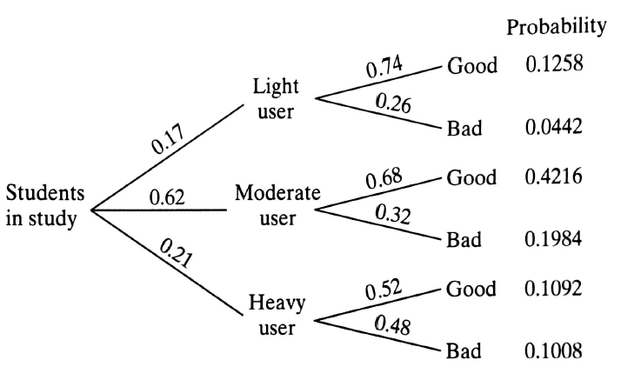

Example: Many employers require prospective employees to take a drug test. A positive result indicates that the prospective employee uses illegal drugs. However, not all people who test positive actually use drugs. Suppose that 4% of the prospective employees use drugs, the false positive rate is 5% and the false negative rate is 10%.
What percent of people who test positive actually use drugs?

HW: 63, 65, 67, 69, 75, 79, 81, 97-99

