Section 5.2 - Probability Rules (pp. 305-314)
1. Definitions
- Sample Space -

- Probability Model -

- Event -

- Mutually Exclusive -

Example:

2. Basic Rules of Probability
- The probability of any event is

- All possible outcomes together must have

- If all possible outcomes in a sample space are equally likely, the probability that event A occurs can be found using the formula

- The probability that an even does not occur is

- If two events have no outcomes in common, the probability that one or the other occurs is

Basic Probability Rules
- For any event A, $0≤P(A)≤1$ .
- If $S$ is the sample space in a probability model, $P\left(S\right)=1$.
- In the case of equally likely outcomes,
$$P\left(A\right)=\frac{number of outcomes corresponding to event A}{total number of outcomes in the sample space}$$
- Complement rule: $P(A^{c}) = 1 - P(A)$ .
- Addition rule for mutually exclusive events: If A and B are mutually exclusive,
$P(A or B) = P(A) + P(B)$

Example - Randomly select a student who took the 2013 AP Statistics exam and record the student’s score. Here is the probability model:
Score 1 2 3 4 5
Probability 0.233 0.183 0.235 0.224 0.125
(a) Show that this is a legitimate probability model.

(b) Find the probability that the chosen student scored 3 or better.

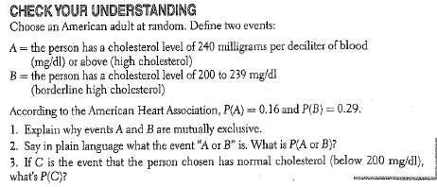

3. Two-Way Tables and Probability
When we are trying to find probabilities involving two events, a two-way table can display the sample space in a way that makes probability calculations easy.
Example - What is the relationship between educational achievement and home ownership? A random sample of 500 people who participated in the 2000 census was chosen. Each member of the sample was identified as a high school graduate (or not) and as a homeowner (or not). The two-way table displays the data.
 | High School Grad | Not a HS Grad | Total
Homeowner | 221 | 119 | 340
Not a homeowner | 89 | 71 | 160
Total | 310 | 190 | 500
Suppose we choose a member of the sample at random. Find the probability that the member
(a) is a high school graduate.
(b) is a high school graduate and owns a home.
(c) is a high school graduate or owns a home.

General Addition Rule for Two Events
If A and B are any two events resulting from some chance process, then
$$P\left(A or B\right)=P\left(A\right)+P\left(B\right)-P(A and B)$$

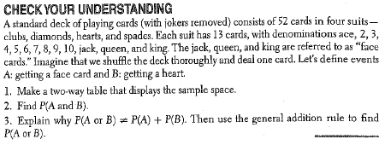

4. Venn Diagrams and Probability
A^{C}

S

S

S

Examples – pp. 312-13

Application: According to the National Center for Health Statistics, in December 2012, 60% of US households had a traditional landline telephone, 89% of households had cell phones, and 51% had both. Suppose we randomly selected a US household in December 2012.
- Make a two-way table that displays the sample space of this chance process.
- Construct a Venn diagram to represent the outcomes of this chance process.
- Find the probability that the household has at least two types of phones.
- Find the probability that the household has a cell phone only.

HW - 27, 29, 31-36, 43-55 odd

